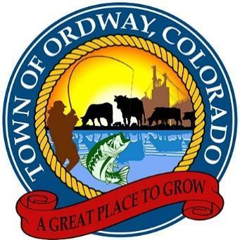

SPECIAL TOWN COUNCIL MEETING
April 25, 2024
4:30 p.m.

Agenda
1. Call to Order
2. The Pledge of Allegiance
3. Roll Call
4. New Business
A. Appointment of Planning & Zoning Board Member
B. Hiring of Seasonal Maintenance Worker
C. Close off 4th Street and Colorado for Ordway Senior Center Craft Fair May 18, 2024
5. Next meetings or work sessions: May 13, 2024
6. Adjournment

The following Call-in information is provided for remote attendance.

April 25, 2024 Town Council Meeting
Special Town Council Meeting
Apr 25, 2024, 4:30 – 5:30 PM (America/Denver)
Please join my meeting from your computer, tablet or smartphone.
https://meet.goto.com/837804533
You can also dial in using your phone.
Access Code: 837-804-533
United States: +1 (646) 749-3122
Karen Gates, Town Administrator Date

