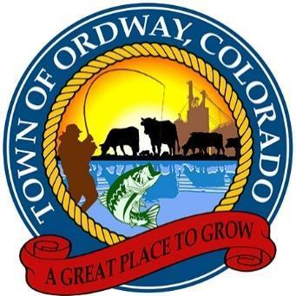

TOWN COUNCIL MEETING
July 10, 2023
Agenda
1. Call to Order
2. The Pledge of Allegiance.
3. Roll Call
4. Additions/Changes to the Agenda:
5. Approve Changes to the Agenda:
Approve Agenda with changes:
6. Approve June 26, 2023, Minutes
7. Public Comment: (those individuals interested in speaking, please sign in at the
beginning of the meeting. Comments are restricted to five minutes per person.
A. Council Comments
8. Old Business-
A. Faw Wells Update
B. Town Hall Update
C. 2019 Audit Update
D. Cemetery Fence Update
E. CML Conference Update
F. Broadband Update
G. Brownsfield Update
H. Eligibility Survey Update
9. New Business
A. Purchase of a new laptop for meter reads
B. Sanitation Rate Increase Ordinance
C. Purchase of a second computer monitor for Administrator and Clerk
D. Discussion of possible purchase of building at 315 Main Street
E. Cemetery headstone issue-Rusher
F. Updating of Employee Handbook
G. Restructuring of job duties in Town Hall
H. Creation of an ordinance for theft of utilities
I. Approval for race on town property
J. DOLA update
K. Approval to apply for a DOLA planning grant to create an asset management plan
L. Purchase of a new sign for the cemetery
M. Approval to block off street for Columbine Saloon for Crowley County Days
N. New map of the Town of Ordway adding the two new streets for the Crowley County Clerk & Recorder
O. Approval to purchase replacement playground equipment for South Park and Conestoga Park
P. Approve Fall 2023 Demolition Sites
1. 132 Arkansas 2. 227 Arkansas 3. 305 Arkansas 4. 319 Arkansas
5. 502 Otero 6. 431 Main 7. 215 E. 4th 8. 601 Idaho

10. Executive Session- Pursuant to C.R.S. 24-6-402 (4), executive session may be entered into for
the purpose of discussing personnel, property, legal advice, matters to be kept confidential
by law, security, and negotiations.
A. Water Matters B. Legal C. Sheriff’s Contract D. Personnel E. Waste Connections Contract

11. Sugar City Disposal Matter

12. Next meetings or work sessions: July 24, 2023

13. Adjournment

The following Call-in information is provided for remote attendance.

July 10, 2023 Town Council Meeting
Town Council Meeting
Jul 10, 2023, 6:00 – 8:00 PM (America/Denver)
Please join my meeting from your computer, tablet or smartphone.
https://meet.goto.com/206528029
You can also dial in using your phone.
Access Code: 206-528-029
United States: +1 (408) 650-3123
Karen Gates, Town Administrator Date

